Dear GDA member, carer/assistant, supporter

2017 Saffery Rotary Walk – GDA accessible route
This letter has been adapted for anyone under taking the last legs of the Saffery Rotary Walk coordinated by the GDA/Access for All.

There is various information below but also on our GDA facebook page, blog www.gda.org.gg

- Registration
This pack is for members and supporter of the GDA and Access for All who wish to take part in this community event but may not be able to complete the whole walk or certain sections due to access needs.

All other walkers need to register with direct please on http://www.safferyrotarywalk.com/

All registrations for the Access legs need to be through Karen at the GDA 07781 467 316. info@disabilityalliance.org.gg Closing date: 19th May (2 weeks before the event)
There is a £15 registration fee for all walkers please make cheques payable to the Guernsey Disability Alliance and we will forward one cheque to Saffery Rotary Walk. With the £15 registration you will receive a T Shirt and official Lanyard (Walkers identity badge). There is no fee (t-shirt/lanyard) for parents/carers or walk companions.

- Chose a starting point
Access walker’s registration and start will take place at the three checkpoints. Two of these are Saffery Rotary Walk official check points; Chouet and Bordeaux. The third at Admiral Park, is a GDA/Access only start point only manned by volunteers and Karen Blanchford. Please note the times are flexible depending on walking speeds
Chouet (official start) arrive at 10am for a 10:30 start
Bordeaux (official start) arrive at 1pm for a 1:30pm
Admiral Park (GDA Access route only) arrive at 3pm for a 3:15pm start
Finish Liberation Monument we aim to finish about 4pm
You will need to give them your name and Walker ID number when you start.

Please note we all aim to finish at 4pm as there will be a press welcome and special guest. Please work your walk time back from that arrival time depending on the pace you walk (or your slowest walker)

- 2017 Saffery Rotary Walk T-shirt
We will finalise numbers and collect the T shirts from the Saffery Rotary committee 24th May. I will get these to your leaders as soon as possible after this date.
Please wear the official T shirt on the day as it helps the organisers identify walkers around the route
- This does not apply to the Scouts, who will be in their uniform or carers who have not registered so will not have a T shirt

- Walker ID Card and lanyard (registered walkers)
IMPORTANT: Only registered walkers will be given a Lanyard (neck walker ID) please wear this at all times as this will help the organisers identify you throughout the walk. Carers or walking companions will not have Lanyards or ID.

- Sponsorship form
Our preference for sponsorship money is:
- Make a bank transfer to Saffery Rotary Walk (with your walk number in the reference field)
- You can also donate online https://race-nation.com/donate/170 but please make sure you add your name (GDA) and importantly your walker ID number
- Bring a cheque payable to: Saffery Rotary Walk or send /drop it in the offices of Saffery Champness (at La Tonnelle House, Les Banques, St Sampson) at any time Monday to Friday between 9.00am - 5.00pm.
If you are not able to do this please bring any sponsorship monies on the day and Karen will bank it for you.

- 2017 Booklet for Walkers – available with your T-shirt and ID after 24th May

- Saffery Rotary Walk car park sign (at the end of this letter)
Please display this on your windscreen at Chouet, Bordeaux or Admiral Park
Scouts
As with last year the Scouts will be waking with our members to learn more about disability locally, if you are happy to, please share openly with them about your condition, how it impacts on your life and what changes you would like to see locally to ensure the island is more inclusive.

Extra notes:

Water and Water Bottles
Plenty of water should be drunk on the day. A 2% drop in body fluid relates to a 20% drop in performance. If at any time your urine is dark then you are not drinking enough but, remember, by then it might be too late.

We recommend that you bring a water container with you. For those without, a refillable bottle will be available at Chouet, Bordeaux and Admiral Park. There is a water standpipe at the Liberation Monument and at each of the official checkpoints (Chouet and Bordeaux).

Dress
Clothing is a matter for the individual but should be comfortable and take the weather conditions into account. When walking distances though, knee length lycra shorts under your kit are good, they stop legs from chafing, keep the leg muscles warm and keep your legs warm even in inclement conditions. For those of you who didn’t know, denim jeans are a nightmare on this type of event, and will just about guarantee chafing, etc.

Physical preparation
Helpful videos and training tips can be found in the walker information on our website www.safferyrotarywalk.com.

Care of your feet
Soaking your feet in surgical spirit should be done in plenty of time and will help to prevent blisters. Toenails should be cut square across, as rounding the nails can lead to ingrown toenails.

"Pairs” of socks are an absolute must, as any movement in the shoe/boot will be taken mainly by the 2 layers of socks and not the foot and sock, i.e. reducing the chance of blisters. The inner pair of socks should be thin, i.e. 1000 mile socks etc. You can also cover your feet in Vaseline before you put the inner sock on. Getting a blister comes in stages and you will get what they call a hotspot before a blister starts, it is imperative to get some protection on. Compeed is very good blister protection. If you do get a hotspot and put a covering on, then cover in Vaseline before the sock goes back on. Footwear is whatever is most comfortable for the individual, be that walking boots or trainers. You may find different footwear for the cliffs and the flat is a good idea.

WARM UP
Stretching should be a whole body stretch, but with extra stretches for the legs. Stretches should be comfortable and to a point of mild tension but should not hurt (quads, hamstrings, calves etc.) with no bouncing on the stretches.

WARM DOWN
Stretches should be done at the end of the walk. These can be the same as before but now need to be done thus: stretch for 20 seconds and hold, then extend the stretch and hold for another 10 seconds. These are called developmental stretches and will help to stop the build-up of lactic acid in the muscles.

Retiring
If you have to retire please tell a marshal at a checkpoint (if you start at Chouet) that you are not continuing or call or text Karen on 07781 467 316. If you are between checkpoints please call 07781 168889

Volunteers
We are very fortunate that Barclays and Aon have offered to support us in this event as well as our own volunteers. They will be assisting with the Admiral Park checkpoint and road crossing as well writing social media articles/blogs on what they learn as they shadow you and the Scouts. Please let us know if you do not want your photo taken or to feature in the article. Olly Tracey of OnScreen Creations will be filming and interviewing for us to capture the event, your energy and enthusiasm so please open up and share what you have learnt.
ITV has named Access for All as their charity for the year and will film some of the walk.

Sponsorship prize
Anyone raising more than £200 in sponsorship will be automatically entered into a draw, the prize for which is an overnight stay for two at the Hotel de Havelet with a meal for two in the Wellington Boot Restaurant.

Thank you
We wish to thank the Saffery Rotary Walk committee, Waitrose and all the volunteers for making the walk accessible to disabled islanders. It is an important part of being involved in the community.

Please find the details of the 28 local charities you are raising funds for. We would urge you to raise as much sponsorship as you are able for these worthy Guernsey charities. Your co-operation in this is much appreciated. Sponsorship can also be donated remotely through the ‘giving’ section of our page on the Race Nation website:-

PLEASE publish this to your friends, colleagues and family both locally and further afield.
Every pound of sponsorship raised by walkers passes to our island charities, which include many of the GDA member charities and groups and many other groups we are linked with or provide invaluable services to the 13,000 islanders with a disability.

Contact points:
- Karen Blanchford (GDA): 07781 467316
- Scout Lead: Julie Hutchins
- Wigwam lead: Debbie Aldous
- Cystic Fibrosis lead: Mike Read
- Saffery contact centre: 07781 168889
- Support – at Admiral Park TBC

The selected projects for 2017 are:
- Grow Ltd - providing training for staff and service users in the care of individuals with learning disabilities
- Safer - supporting a 3 day training course for coordinators and facilitators. Safer seeks to enable all islanders to enjoy a life free of domestic abuse, coercion and harm.
- Les Voies School - supporting the provision of Computer Aided Design (CAD) equipment for children and young people that experience Social, Emotional and Mental Health Difficulties (SEMH).
- Headway Guernsey - providing new laptops to help re-develop skills of members. Headway supports people and families recovering from brain injury.
- Vale School PTA - supporting the purchase of play equipment for the playgrounds.
- Philippi Guernsey LBG - supporting a counsellor training course. Philippi Guernsey LBG exists to provide professional and accessible counselling training and counselling to those within the church and community in the Bailiwick.
- Active - providing afternoon tea for 150 people with learning disabilities at the Peninsular with live musical entertainment.
- Ormer FC - providing an entry fee to enter an 8-a-side league and offering experience of competing at an elite level.
- Wigwam support group - funding towards the cost of centralised IT systems during the process of moving all of IT needs to cloud based solutions.
- Guernsey Disability Alliance - providing funding for a campaign to raise awareness of issues facing people with disabilities.
- Jumbulance Holidays--providing support to take 10 disabled people to Lourdes with helpers and a medical team of 4.
- Multiple Myeloma Support Group - supporting training workshops run by specialists for Bulstrode House nurses.
- Autism Guernsey - providing a 2-day training programme for 25 parents to learn communication and other skills.
- St John's Ambulance - providing safety equipment for volunteers - boots, hi viz jackets and helmets plus a contribution towards training.
- Guernsey Childs Contact Centre - providing a large tv and games console.
- Guernsey Hard of Hearing Assoc - providing hearing aids for those who fall outside States support but are financially challenged to fund this vital equipment.
- Lihou Charitable Trust – funding refurbishment of their dining room.
- Guernsey Chest and Heart - funding replacement of 2 Tanita body scales.
- CI Air Search - providing a TETRA phone to improve communications on rescues.
- Access For All - funding experts from the UK to train people locally in Access auditing and the Equality Act.
- Guernsey Sailing Trust - provision of a 20hp safety boat outboard engine.
- Home Start Guernsey - supporting the training of volunteers.
- Notre Dame PTA - Support for improvement programme for a small grassed area on the school grounds which is often had to be closed with heavy use.
- Bailiwick of Guernsey Victim Support and Witness Service - funding training and education events to staff, volunteers and some outside agencies and the writing of training & education material.
- Guernsey Art Network - funding art workshops for adults and children.
- Constables of StPP Xmas lights - supporting the replacement of lights for the Commercial Arcade area.
- Forest School PTA - funding the replacement of junior playground equipment.
- Edible Guernsey 'Growing Skills' at Edible Guernsey Farm - providing a horticultural polytunnel and raised planters/beds and rendering them suitable for disabled access, together with necessary tools.-

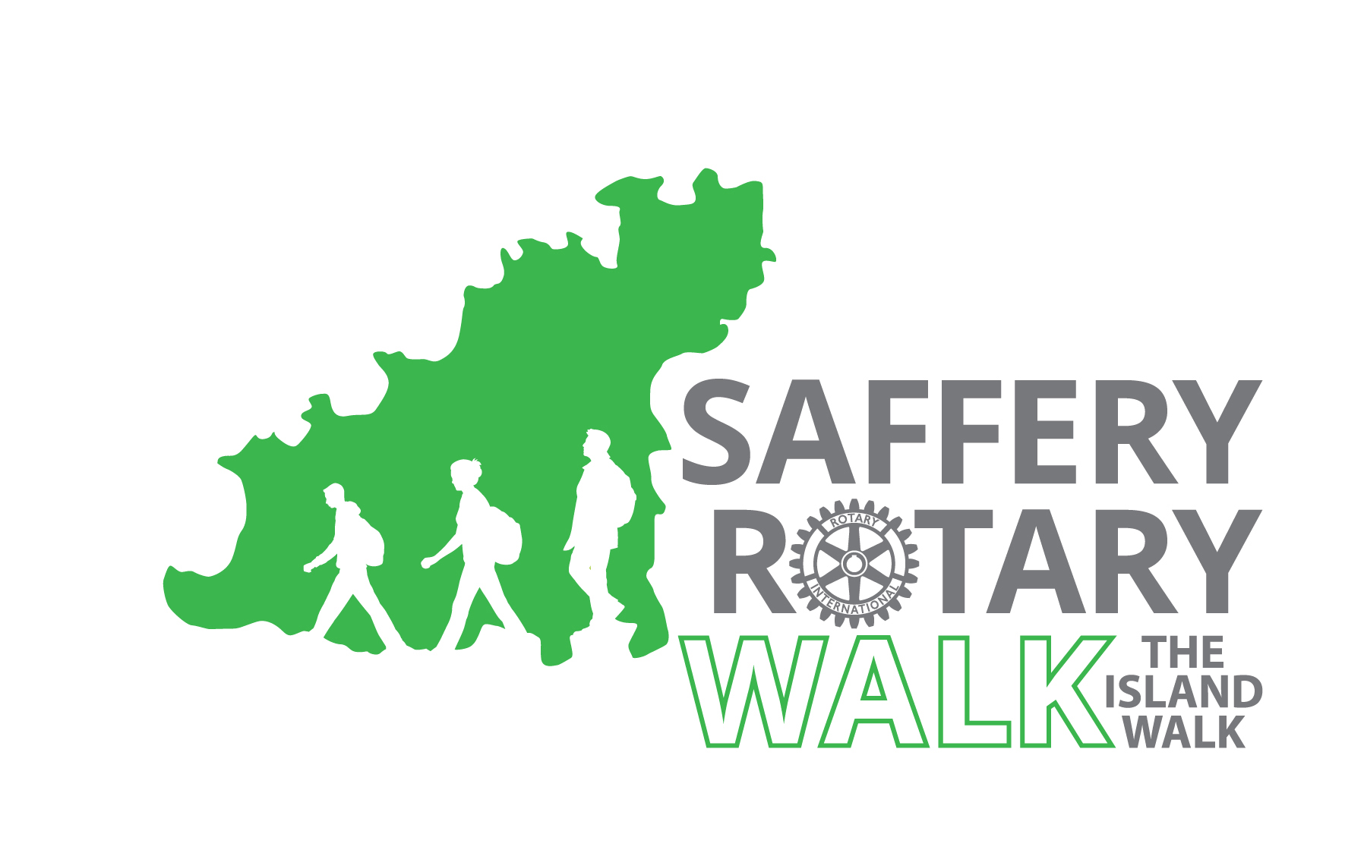 | Saffery Rotary Walk  Saturday 3 June 2017

SRW Walker
GDA/Access for All leg

GDA contact details
Karen Blanchford
Executive Director - Guernsey Disability Alliance
Email: karen@disabilityalliance.org.gg
Mobile: 07781 467 316
Website: www.disabilityalliance.org.gg
Facebook: www.facebook.com/GuernseyDisabilityAlliance
Twitter: @GDA_Disability
LinkedIn: https://www.linkedin.com/in/karen-blanchford-39900010
Address: Calliope, La Planque Lane, Forest GY8 0DR

