Celebrating resilience – The EJ Blight trophy 1917-2017

Recently we published the latest findings from the Guernsey Young people’s survey. The survey asks 2000 young people to explain their views, attitudes and behaviour about being a teenager in Guernsey today.
The survey is a fascinating document that demonstrates that the 21st Century is the best of times and the worst of times (to misquote Dickens) for growing up as a young person.
Our summary reflects this mix of good and not so good:
The findings of the Guernsey Young people’s survey 2017 reflect the challenges that life in the 21st Century presents to Guernsey teenagers. Broadly the findings are positive and demonstrate that young people are coping well with the increasing pressures of 21st Century life. Most young people report that they are happy with their lives, enjoy school, have colleagues with whom they can share problems and are aware that that they are in control of their health. However they are not immune from the pressures that all young people face. In particular, there is a significant number who report that they are unhappy and find life stressful.
One of the most important qualities that young people need to thrive in the 21st Century is resilience.
By resilience we mean the ability to cope or ‘bounce back’ after encountering negative events, difficult challenges or adversity.
Learning about resilience will be a cornerstone of our new Guernsey curriculum. In a nutshell this means that children and young people keep going when things get hard as they believe errors and challenge show they are at the edge of their comfort zone which leads to more progress and depth in learning.
To celebrate this aspect of our new curriculum we will be presenting a trophy that has a very special significance this year.
The EJ Blight trophy was first presented in 1917 and commemorates the life of EJ Blight , a Guernsey man who died in action during World War 1 on March 10th 1917.
Overleaf we have attached some details of EJ Blight.
Lieutenant EJ Blight would have seen action for two years before his death. Daily he would have had to overcome the terrible, grim realities of war. He would have had to keep going despite losing close friends and comrades in one battle after another.
There is no better example of resilience.
One hundred years on we want to commemorate Lieutenant Blight’s bravery by presenting the EJ Blight trophy to a Guernsey young person, group or club who have experienced tough times but showed resilience in overcoming adversity.

The EJ Blight Trophy for Resilience
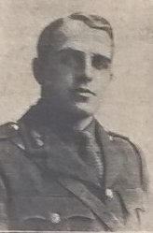
EJ Blight 1896 – 1917
‘Here remains a hero of heroic example and noble obligation’
A keen sportsman excelling in shooting, football, water polo, boxing, cricket, hockey and swimming.
Teacher at the Grammar School and Clerk to the Primary Education Committee.
Volunteered for the Royal Irish Regiment in 1915, Joined the Northumberland Fusiliers in 1915.
Died in action 10th March 1917.

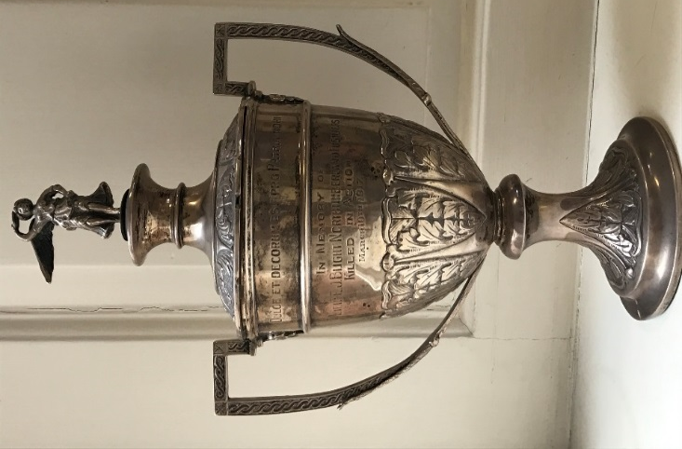
World War 1 was a terrifying experience for so many young men who volunteered. EJ Blight was involved in warfare for nearly three years until his death one hundred years ago in March 2017.
To remember EJ Blight and the other Guernsey men and women whose lives were blighted by World War 1 we are relaunching the EJ Blight Trophy – last presented in 1985.
We are looking to present the trophy in recognition of examples of resilience from young people in Guernsey.

How to enter
If you know of a young person or group of young people (any age up to 21 years) who have demonstrated resilience then why not nominate then for the EJ Blight Trophy?
Please send a citation of 100 words or less explaining why that young person or groups of young people have been nominated to Alun Williams at alun.williams@gov.gg - by Wednesday 27th June^{th}
Telephone: 07911 728059 for more information

