

**GUIDE TO ACCESSIBLE TAXIS**

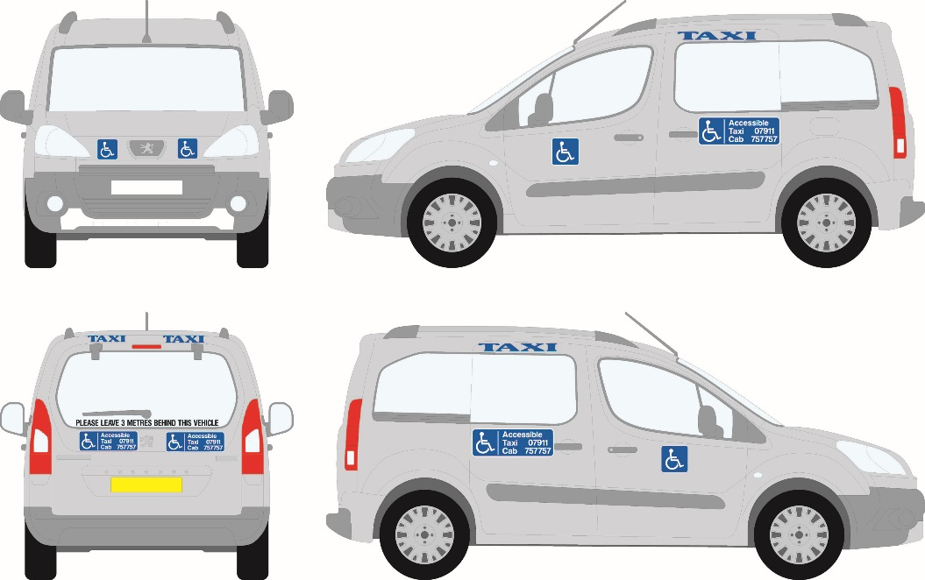

**What does “Accessible Taxi” mean?**

Accessible taxi drivers have had additional training, the vehicle has been specially adapted to carry a wheelchair if required, and the cab has good internal lighting to assist people who may have a visual impairment.

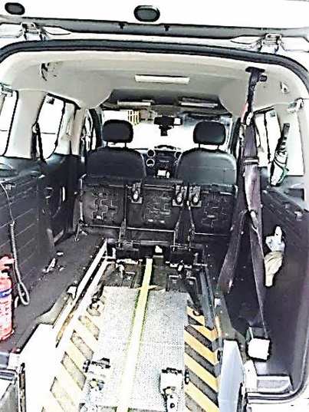All of the vehicles have wide, shallow ramps.

The driver will use a winch system to help a passenger who uses a wheelchair to enter and exit the vehicle safely.

Once inside the vehicle the wheelchair will be safely secured to the floor of the vehicle, and the passenger seated in the wheelchair provided with a seatbelt.



Accessible taxis display the international access symbol on their vehicle.

**Accessible taxi contact details**

There are currently four licenced accessible taxi operators. They can be contacted by phone, text or email.

**Harvey’s Taxis** telephone 07781 406222

Email: [harveystaxis@yahoo.com](mailto:harveystaxis@yahoo.com)

**Ashley Lacey** telephone 07781 178 178

Email: [ashleystaxicab@icloud.com](mailto:ashleystaxicab@icloud.com)

**Daniel Le Sauvage** telephone 07781 162 662

Email: [getaroundguernsey@suremail.gg](mailto:getaroundguernsey@suremail.gg)

**Pete’s Accessible Taxi** telephone 07781 111511

Email: [pattaxi511@gmail.com](mailto:pattaxi511@gmail.com)

If you are unsure as to whether a vehicle will meet your requirements, please discuss this with the driver.



**Accessible taxi drivers**

Each accessible taxi driver has a certificate to demonstrate they have undergone and passed a training course on safe passenger handling and they will carry standard taxi identification.

**PUBLIC SERVICE VEHICLE PERMIT HOLDER –**

**IDENTITY CARD**

**NAME: xx xxxx**

**CATEGORIES: TAXI/OMNIBUS**

PHOTO

**DATE: xx xx xxxx**

Taxi drivers will assist with wheelchair access and will ensure that wheelchairs are properly and safely secured before setting off on a journey. They will also assist passengers to disembark at the end of their journey too.

Taxi drivers are also trained to help people with moderate walking difficulties, as well as those with impaired vision, hearing, or a learning difficulty.

**Booking an Accessible Taxi**

Accessible taxis can operate from ranks AND they can be pre-booked by phoning the taxi operator or taxi driver. You are recommended to book 24 hours in advance, but if you forget, or need a taxi in a hurry, contact the drivers to see if one is available.

**TAXI**

The driver only has to use the meter if you hire the cab at a taxi rank.

If you book the taxi in advance, you and the driver can agree a fixed price if either of you are happy to do so, or the driver can use the meter.

**Tariffs**

****Taxis charge different rates depending on how many people are in the cab, what time of day it is or whether it is a Public Holiday.

Make sure that the driver has the meter on either tariff 1 (normal hours) or tariff 2 (nights calls/Public Holidays). It should only be on tariff 3 (or above) if there are 5 or more passengers in the cab.

The driver should not set the meter to tariff 3 or above just because there is a wheelchair user in the cab.

Normal Hours are:

Monday to Friday 7am -10pm

Saturday and Sunday 7am -7pm

Public Holidays:

Monday - Friday 10pm - 7am

Saturday and Sunday 7pm -7am

**Waiting times**



Accessible taxi drivers understand that disabled people might take a little longer to get into a taxi.

There should not be any charge on the meter until the taxi drives off. However, if the passenger is not ready on time, then the driver may charge for the time they are kept waiting if it is longer than five minutes.

# What to do if you have a problem



Visit us or write to us at:

Traffic and Highway Services

PO Box 145

Bulwer Avenue Office

Bulwer Avenue

St Sampson’s

Guernsey

GY2 4LR



Contact us by phoning:

01481 202227



Contact us by emailing:

Traffic@gov.gg

https://www.gov.gg/psv