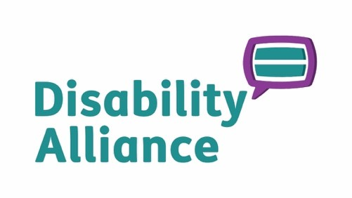

Guernsey Disability Alliance LBG (the “Company”)
(Incorporated in Guernsey with registered number: 55102 and registered charity number CH41)
FORM OF PROXY For use at the Annual General Meeting to be held on Wednesday 3rd June, 2025

I ………...................................................................…………………...…….................... (in Block Capitals) of

.............................................................................................................…………….…... being a member of the Company HEREBY APPOINT the Chair of the meeting (see note below) or failing her

....................................................…................................................... as my proxy to vote for me and on my behalf at the Annual General Meeting of the Company (the “AGM”) to be held on 3rd June, 2026, and at any adjournment thereof and in respect of the Resolutions set out in the Notice of the AGM to vote as indicated below.

ORDINARY RESOLUTIONS | Agree | Disagree | Abstain
Election of Directors
- THAT Catherine Hall be re-elected as Chair of the Company
Proposed by Rob Harnish
Seconded by Carol Le Page

- THAT ********* be elected as Honorary Treasurer of the Company
Proposed by Catherine Hall
Seconded by Carol Le Page

- THAT Jamie Hall be re-elected as Honorary Secretary of the Company
Proposed by Rob Harnish
Seconded by Carol Le Page

- THAT Rob Harnish be re-elected as a Director of the Company
Proposed by Catherine Hall
Seconded by Carol Le Page

- THAT Carol Le Page be re-elected as a Director of the Company
Proposed by Catherine Hall
Seconded by Rob Harnish

Financial Statements
- THAT the annual accounts for the year ended 31st December 2025, together with the Directors’ Report on those accounts, be received.

Note: the audit waiver continues indefinitely subject to any review by the Executive.

My email address (if applicable) is:

...............................................…………………...……......................………………..

Signed ..............……............................................................

Dated ....…………........

Upon completion, please return this Form of Proxy to the following address, so as to arrive no later than 12:00 noon on Wednesday 3rd June 2026.

Guernsey Disability Alliance,
First Floor (West),
Island House,
La Grande Rue,
St Martins,
Guernsey,
GY4 6RU

Or by email to carol@disabilityalliance.org.gg

Note
A member entitled to attend, speak and vote is entitled to appoint one or more proxies to exercise all or any of his/her/its rights to attend, speak and vote at the AGM. A proxy need not be a member of the Company. If you wish to appoint a person other than the Chair of the AGM, please insert the name of your chosen proxy holder in the space provided on the Form of Proxy.

